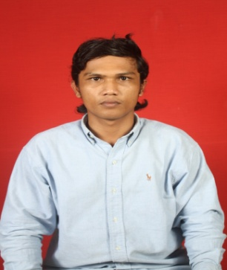

**Ilham ambia**

Jl.Oman jaya 2 THB Rt/Rw 003/008

Pejuang,Medan satria– Bekasi

Mobile Phone: +6282168159794 e-mail to: ilhamambia04@gmail.com

**Objective:**

**Available Position,**able to explore my professionalism in work.

**Personal Particular:**

* Place/Date of Birth : Lhokseumawe , 17 Oktober 1992
* Hobby : Football
* Gender : Male
* Race : Indonesia
* Height/Weight : 175 cm/70 kg
* Identity Card No. : 3275061710920013

**Education:**

* 1998 – 2004 : SD 2 Swasta Yayasan Pendidikan Arun
* 2004 – 2007 : MTS Mahad Alzaytun
* 2007 – 2010 : MA Mahad Alzaytun

**Occupation:**

* Helper,gas metering,scada otomations system and telecommunications project,pt arun natural gas lliquefaction (agustus 2014 up to december 2014)